**Exercise 2 : Financial Forecasting**

🡪**Implementation**

* **Formula / Logic :**
  + 1. **Recursive Formula :** futureValue = currentValue*(1+growthRate)^years

We will use recursion to multiply the value by (1+growthRate) for each year

* **How it works :**

1. The **futureValue** method calls itself, each time multiplying the value by **(1+ growthRate)** and reducing the number of years by 1.
2. When years reach 0 , it return the current value.
3. The result in printed in the main method

**🡪Code :**

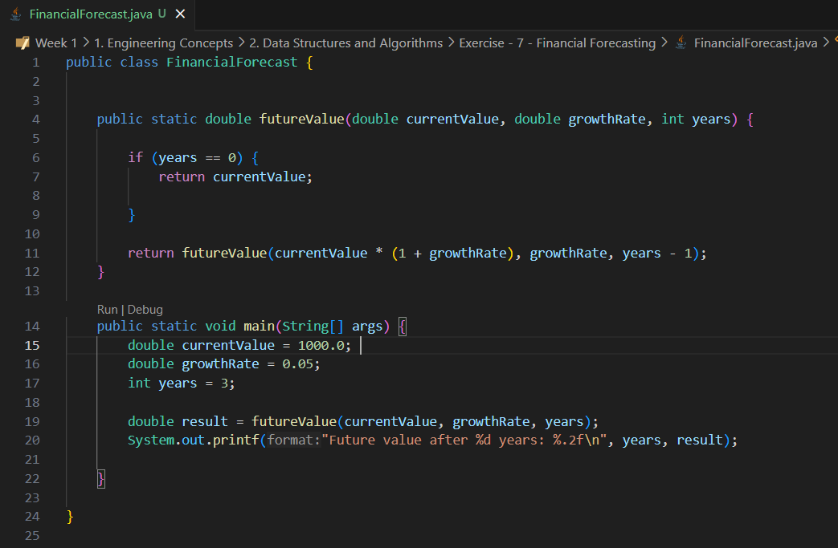

* **Output :**



🡪**Analysis**

* **Time Complexity:** O(n) , where n is the number of years
* **Optimization :** For large n, use iterative approach to avoid stack overflow and repeated calculations.